DEVELOPMENT OF SELF-BALANCING ROBOT AND ITS CONTROLS IN UNEVEN TERRAIN
TABLE OF CONTENTS

LIST OF FIGURES 3
LIST OF TABLES 4
NOMENCLATURE 5
ABSTRACT 6
CHAPTER 1 7
INTRODUCTION 7
CHAPTER 2 9
LITERATURE REVIEW 9
CHAPTER 3 17
METHODOLOGY 17
3.1 DERIVATION OF GOVERNING EQUATION OF MOTION 17
3.2 APPLYING STATE SPACE MODEL 19
3.3 DESIGN OF THE ROBOT 20
3.3.1 STRUCTURAL DESIGN OF THE ROBOT 20
3.3.2 FOUR-CLAW GRIPPER AND ITS KINEMATICS 21
3.3.3 ROBOTIC ARM AND ITS KINETICS 23
3.3.4 FABRICATION TECHNIQUES OF THE ROBOT 24
3.4 ELECTRONICS AND CIRCUIT DIAGRAM 27
3.5 DESIGN OF CONTROL SYSTEM 29
3.5.1 SIMULATION OF POLE-PLACEMENT CONTROL TECHNIQUE 30
3.5.2 SIMULATION OF LQR CONTROL TECHNIQUE 30
CHAPTER 4 32
RESULT & DISCUSSION 32
4.1 RESPONSES OF THE SYSTEM FROM THE POLE-PLACEMENT CONTROL TECHNIQUE 32
4.2 RESPONSES OF THE SYSTEM FROM THE SIMULATION OF LQR CONTROL TECHNIQUE 33
4.3 ANALYSIS OF THE RESPONSES AND DISCUSSION 34
CHAPTER 5 36
CONCLUSION AND FUTURE WORK 36
REFERENCES 37

LIST OF FIGURES

Figure 1 . Simulation results for PID control based on dynamic model [1] 9
Figure 2 . LQR control simulation [7] 10
Figure 3 . Experimentally obtained history of tilt angle: PID controller (top), PI - PD controller (bottom) [16] 13
Figure 4 (a) LQR control when initial angle is 3. (b) LQR control when initial angle is 20 [24] 14
Figure 5 . Free Body Diagram of a Simple Inverted Pendulum 17
Figure 6 Illustration of the structural design of the robot – (a) Front view; (b) Side view; 20
Figure 7 Illustration of the four-claw-gripper – (a) Isometric view; (b) Side view; (c) Picture of the four-claw gripper with its driving bolt 21
Figure 8 – (a) Illustration of the slider crack mechanism; (b) Pictorial analogy of the gripper design with the slider crank mechanism; 22
Figure 9 Illustration of the robotic arm and its degrees of freedom of movement 23
Figure 10 Illustration of the Centre of gravity of the robotic arm – (a) Front view; 23
Figure 11 Illustration of the Mk3 version – (a) Front view; (b) Side view; 25
Figure 12 Comparison of enclosures – (a) Mk3 version; (b) Mk7 version 26
Figure 13 Comparison of the wheels – (a) Mk3 version’s 170mm diameter wheels; 26
Figure 14 Integrated electrical circuit diagram of the robot and the robotic arm 27
Figure 15 Sensors Input-Output ports diagram for the robot and the robotic arm 28
Figure 16 Picture of the console 28
Figure 17 Circuit diagram of the console 29
Figure 18 The response Pole-placement control (a) The change in position of the cart with respect to time, (b) The change in the angle $θ$with respect to time. 32
Figure 19 The response of LQR control (a) The change in position of the cart with respect to time, (b) The change in the angle $θ$with respect to time 33
Figure 20 (a) The step response of LQR control, (b) The step response of pole-placement control 35

LIST OF TABLES

Table 1 Comparison of fabrication techniques 25
Table 2 Parameters of the inverted - pendulum 29
Table 3 The simulation results of Rising time, Settling time for the cart, angle $θ$, in seconds 34

NOMENCLATURE
PID - Proportional Integral Derivative
DIP - Double Inverted Pendulum
LQR- Linear Quadratic Regulator
TWRs -Two-Wheeled Robots
CIPS - Cart-Inverted Pendulum System
TWIP - Two-Wheeled Inverted Pendulum

ABSTRACT

The inverted pendulum is a classic example for highly unstable system that is used to study and experiment different control systems. In recent years, the problem of stabilizing an inverted pendulum has been of particular interest in the development of self-balancing robots, such as the Segway. Inverted pendulum theory is frequently used by self-balancing robots to maintain equilibrium. The centre of mass of two-wheeled robots, where this technology has been widely studied and used, is located above the wheels. However, other aspects, including the permitted degree of tilt, must be taken into account when constructing self-balancing robots for rough and uneven situations. This necessitates the creation of a three-dimensional self-balancing model that takes these elements into consideration. To counter the uncertainties, the study is carried by deriving the state space model for the inverted pendulum. The mathematical modelling is performed using Euler-Lagrange method by finding the difference between kinetic and potential energies resulting in two second order differential equations. We linearize the equations in order to optimize the performance at the equilibrium point. Here, two second order differential equations are converted into four first order differential equations. This allows us to use the LQR control system, which is based on linear systems theory, to design a feedback controller for the pendulum. Since there wasn’t work done in stabilizing inverted pendulum self-balancing robot in uneven and swampy terrains such as agricultural fields, the present work has been focusing to address these issues. Different controls systems such as LQR (Linear Quadratic Regulator) and Pole-Placement are adapted to minimize the cost function that stabilize the system to be in upright position when treated with disturbance and experimentally validated to check for better performance. Simulation of this system is carried out using MATLAB in which the input and output control are signals that are applied as torques to the pendulum. The single inverted pendulum consists of a robotic arm which is used to grip objects using its four-claw gripper. To experimentally validate the system a prototype of the inverted pendulum is built with Arduino mega as the controller. In order to sense the angle of simple inverted pendulum and the robotic arm MPU6050 module is utilized. The data of translational moment of the robot is obtain though the OE37 encoder attached to the servo motors driving the wheels. The results show that LQR control system is effective method in stabilizing a single inverted pendulum in terms of stabilizing time, control effort and robustness to disturbances. In addition, LQR resulted in low settling time when subjected to the step input. The prototype of the robot is tested for arbitrary input angles and verified for the ability to self-balance on plane surfaces. Additional improvements such as independent wheel control, robust control for arbitrary disturbance and extension to double inverted pendulum are proposed as the future directions of research.
Keywords: Inverted pendulum, Unstable system, Control system, State space model, LQR control system, Euler-Lagrange method.

CHAPTER 1

INTRODUCTION

A well-known and significant research problem in the fields of control engineering and robotics is the self-balancing of an inverted pendulum. The mechanism entails suspending an oscillating pendulum vertically from a mobile cart. The objective is to manage the cart's travel down a linear track so that the pendulum maintains equilibrium at the vertical position. Considering it as an excellent model for testing control theories and algorithms for under-actuated and nonlinear systems, which are frequently encountered in a variety of real-world applications including the robotics, aerospace, and automotive sectors, the control of an inverted pendulum is extensively researched.
The inverted pendulum problem is difficult because it is unstable by nature. The pendulum may go off course due to minute perturbations. The pendulum can sway from its upright posture as a result of minor perturbations, which can tip the balance. By applying pressures to the cart, the movement may be controlled in order to maintain the pendulum's equilibrium. In order to keep the pendulum in an upright posture, the control tactics comprise monitoring the pendulum's motion and using feedback control to change the cart's movement in real-time. The main goal is to minimize the movements of the cart while maintaining the pendulum as near to the vertical position as feasible. Aspects such as the location of the center of mass, permitted degree of tilt etc., must be taken into account when constructing self-balancing robots for rough and uneven terrains. This necessitates the creation of a three-dimensional self-balancing model that takes these elements into consideration. To counter the uncertainties, a comprehensive model robot is studied by deriving the state space model for the inverted pendulum.
Control theory frequently uses state space models to describe the behavior of dynamic systems. They are a technique to use a collection of variables called state variables to describe the state of a system at any given time. The state equation and the output equation, which link the state variables to the system's output, are the two equations that make up a state space model. The state equation specifies how the state variables change over time. The analysis and design of control systems benefit greatly from the use of state space models, which make it simple to calculate system behavior under many input scenarios.
In order to create a state space model while working with non-linear systems, the system must frequently be linearized. The Euler-Lagrange technique can be used in this situation. Based on the concept of least action, the Euler-Lagrange method is a mathematical approach to establishing the equations of motion for a system. This technique is frequently used in control theory to create a linearized model of a nonlinear system that revolves around a point of equilibrium. Because many control design methods, including pole positioning and optimum control, depends on models that are linear, linearization is crucial. We may use these methods to analyze and create controllers for a non-linear system by linearizing it. For system identification and parameter estimation, linearization also enables us to approximation the behavior of a non-linear system across a limited range of operating circumstances.
As an extension a double inverted pendulum is analyzed using the Euler-Lagrange method that is based on the difference between kinetic and potential energies resulting in three second order differential equations. We linearize the equations in order to optimize the equilibrium point. After linearizing, the three second order differential equations are converted into six first order differential equations. This allows us to use the LQR control system, which is based on linear systems theory, to design a feedback controller for the pendulum. For the inverted pendulum problem, several various control strategies have been put forth, ranging from traditional strategies like PID controllers to more sophisticated strategies like LQR control, and adaptive control. The efficacy and complexity of these control mechanisms vary, and they are often chosen depending on the particular requirements of the application.
The hardware to address the problem statement are chosen based on the performance delivery and requirements. Arduino Mega 2560 is used as mother board as it has the desired number of input ports. In order to sense the angle of single inverted pendulum and the robotic arm MPU6050 module is utilized. The data of translational moment of the robot is obtain through the OE37 encoder attached to the servo motors driving the wheels. Simulation results show that LQR control system is the most effective method in stabilizing a single inverted pendulum in terms of stabilizing time, control effort and robustness to disturbances. Moreover, LQR resulted in low settling time when subjected to step input. The experimental model is being tested for achieving self-balancing and validating the LQR control scheme. The future scope for work for improvements can be carried by scaling down the prototype, including on-board storage system, providing computer vision and making it run through artificial intelligence (AI) for computation. The work can be also done in terms of attaching a telescopic arm and furthermore, extensive testing can be done on inverted pendulum cart systems.

CHAPTER 2

LITERATURE REVIEW

Jasmin et al., 2021[1], discussed advantages and use of two wheeled self-balancing robots for the transportation, and focused on the challenges associated with controlling their inherent instability. In this paper mentioned different linear and non-linear control techniques are used to maintain balance and stability. Empirical and PD controls are used by the authors based on the dynamic model. Martins et al., 2017[2] study the importance of equilibrium control for two-wheeled mobile robots, also given use of various control techniques that includes LQR, PID, backstepping, and fuzzy-variable controls. In this paper main objective is to study the physical and dynamical properties of a two-wheeled robot and check different control strategies in order to improve performance, main control algorithms used are PID and position control and also outlines the hardware and software solution implemented for the construction of robot.
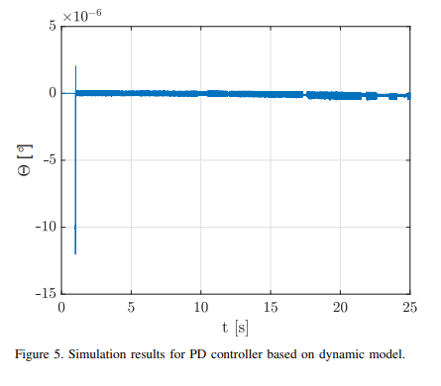
Figure 1. Simulation results for PID control based on dynamic model [1]
Thao et al., 2010[3] discussed on the two-wheeled self-balancing robot control system, gives importance of signal processing and control methods. Designing controllers for nonlinear system, back-stepping control is used as an effective approach. The PID Backstepping controller consists of three control loops like nonlinear control, PD control and PI control for pitch angle tracking, position control, motion direction control. This paper gives overview of hardware, sensor signal processing, mathematical modelling and the design methodology for controller. Azar et al., 2019[4] focused on the control of a two-wheel self-balancing robot and discussed about system modelling in two sections one about DC motor and another one is about mechanical design. Compared two type of controllers PID and 2-DOF PID, results obtained that 2-DOF PID controller approach is much better than Conventional PID controller as the 2 DOF-PID controller has quick response, rejection of disturbances and small errors.
Wei An et al., 2013[5]discussed the development of two-wheeled inverted pendulum robots, including self-balancing robots like the Segway, and their applications as human transporters. It highlights various prototypes and control methods used in these robots. The review emphasizes the challenges posed by the robots' unstable nature, multivariable dynamics, non-linearity, and coupling properties, mentions the use of gyroscopes and accelerometers for sensing inclination and applying torque signals to maintain balance, noted that the limited research on large-scale human transporter vehicles and the lack of comparisons between PID and LQR control methods. Finally, suggested that LQR control shows better performance in controlling such systems based on simulation results. Ahmad et al., 2018[6]focused on the control of two-wheeled robots (TWRs) due to their complex dynamics and non-linearity. TWRs play a vital role in various industries and daily life applications. Different control schemes have been proposed, including neural networks, sliding mode control, fuzzy controllers, and pole placement controllers. Challenges such as robustness, disturbance rejection, and tracking performance have been addressed through various control approaches, discusses the limitations and advantages of these control schemes and proposes the use of feedback linearization, LQR, and back-stepping control for TWRs. The effectiveness of these control approaches is evaluated through simulations. The paper concludes with a summary of the findings and the proposed control strategies' contributions.
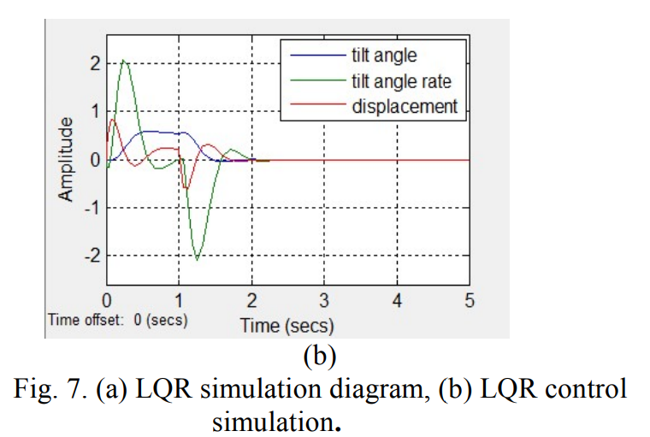
Figure 2. LQR control simulation [7]
Habib et al., 2020[8] discusses the control of inverted pendulum systems, which are challenging to stabilize due to their nonlinear and unstable nature. Various control methods, such as PID control, pole placement, LQR control, and fuzzy control, have been applied to single and double inverted pendulum systems. PSO, GA, and BA are a few of the hybrid control and optimization strategies that have been studied. Through simulation simulations, the paper demonstrates the effectiveness and comparative advantages of these control systems. This study compares and analyses the performance of a linearized double inverted pendulum system with pole placement and LQR control, with Q and R matrices that are GA and PSO optimized. Banerjee et al., 2018[9]highlights the significance of the double inverted pendulum system as a research platform for control system design. LQR control strategy has emerged as an effective approach for stabilizing the system, surpassing other strategies like PID. The focus has been on mathematical modeling, controller design, and robustness to disturbances. Future research may explore advanced control techniques, adaptive strategies, and real-world applications of the double inverted pendulum system.
Singh et al, 2012 [10] conducted a study comparing the performance of a multi-PD controller with pole placement theory to that of a Linear Quadratic Regulator (LQR) in stabilizing a double inverted pendulum system. The study was carried out using MATLAB and Simulink. The results showed that the multi-PD controller with pole placement theory outperformed the LQR controller in stabilizing the linearized double inverted pendulum system. Therefore, the study suggests that the use of a multi-PD controller with pole placement theory is a more effective control strategy compared to LQR, for stabilizing the double inverted pendulum system. Luhao et al., 2010 [11]presented a study on the application of LQR-Fuzzy controlto maintain the balance of a double inverted pendulum system. The study involved deriving the Lagrange equation was used to create the mathematical model of the double inverted pendulum. The control system is based on state variable fusion using optimization control theory. The study's findings demonstrated that the LQR-Fuzzy controller achieved good stability and was able to move the pendulum in advance along the orbit. This suggests that the use of the LQR-Fuzzy control system is an effective strategy for stabilizing the double inverted pendulum system.
Yadav et al., 2012 [12] conducted a systematic study on the Using a LQR controller, the double inverted pendulum (DIP) may be controlled optimally. The aim of this study is to introduce a mathematical model for the analysis of the DIP system's control using MATLAB. According to the study's findings, the LQR controller was successful in lowering the settling and rise time of the DIP system when subjected to a step response. This suggests that the use of an LQR controller is an effective approach for twin inverted pendulum system control. Nalavade et al., 2014 [13]conducted a study on balancing the double inverted pendulum (DIP) in a cart using linearization techniques. The aim of the study was to stabilize the swing up of the pendulum around the point by using the linear quadratic regulator (LQR) technique. The study achieved linearization of this non-linear system by using the Jacobian of the proper cost function, which is obtained by the Euler-Lagrange equation. The optimality was achieved by minimizing the quadratic cost function through the solution of the Riccati equation. The results show that balancing of the DIP on a cart can be successfully carried out by linearization using the LQR technique. This suggests that the proposed technique can be useful in the design and development of control strategies for balancing the DIP system.
Bogdanov, 2004 [14] paper focuses on the optimal control of a double inverted pendulum on a cart. The mathematical modelling is based on the Euler-Lagrange equation, which is converted into six first-order ODEs for simplification. The control is carried out using LQR controller, optimal neural network, and SDRE methods to test their capabilities. The results show that LQR provided near-optimal control in the vicinity of equilibrium since the nonlinear and linear DIPC dynamics are close to equilibrium.Ratnayake et al., 2019 [15]presented a conference paper on the application of various controllers for inverted pendulum systems, including linear and PID regulation and energy-based manage are examples of asymmetric controllers. The study utilized an IMU unit and incremental encoder to measure angles and a using a 12-bit resolution motor driver and 20 Hz PWM signal to drive the motor. The LQR controller was implemented to achieve successfully maintaining equilibrium between the body and pendulum in a straight position and maintaining desirable locations. Overall, the paper highlights the effectiveness of various controllers for inverted pendulum systems and the successful implementation of the LQR controller for control and stabilisation of the position of a moving double inverted pendulum.
Amalia et al., 2017[16]Discusses the Cart-Inverted Pendulum System (CIPS), a traditional benchmark control issue. The CIPS is similar to existing technologies like segways, pendubots, and human walking. Due to its high instability, nonlinearity, non-minimum phase characteristics, and underactuation, CIPS is difficult to manage. The physical limitations of the track length and control voltage make the control design more challenging. In order to reduce implementation problems, this research suggests a novel cart-inverted pendulum model with a DC motor and a mathematical representation of mechanical gearbox. The Linear Quadratic Regulator (LQR) design weighting matrices are used to give a state feedback design method. Simulation experiments demonstrate the effectiveness of the proposed control method in stabilizing the pendulum in an upright angle position while maintaining the cart at the desired position.
Juang et al., 2013[17]discusses the growing presence of mobile robots in civilian spaces and highlights the Segway personal transport as an impressive self-balancing vehicle, explores the diverse research on controlling such systems, including various control methods and their applications. The affordability of commercial sensors and microprocessor boards, particularly Arduino, has enabled the development of two-wheel self-balancing robots. The paper presents a student project that utilizes an Arduino Mega board and implements two control designs, PID and proportional-integral proportional-differential control based on LQR design. The approach proves to be robust, and the paper concludes with experimental results and concluding remarks.Jmil et al., 2014[18]discussed on the optimization of control systems for two-wheeled self-balancing robots and the significance of these robots as test platforms for control system development in various fields. Different control techniques such as pole placement, LQR, PD, PI, and hybrid controllers are discussedalso mentions the use of Kalman filtering and PID algorithms for cost-effective solutions. Examples of successful balancing robots, including the SEGWAY and Legway, are provided. The relevance of these control systems in aiding mobility for the elderly and addresses the modeling and testing of inverted pendulum systems using dual-PID and LQR control techniques. Overall, the paper discusses the importance of optimizing control systems for two-wheeled self-balancing robots and their potential applications in diverse domains.
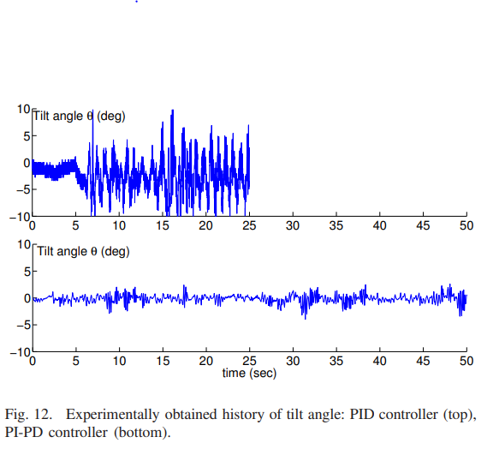
Figure 3. Experimentally obtained history of tilt angle: PID controller (top), PI - PD controller (bottom) [16]
Gan et al., 2010[19]discussed the significance of two-wheeled self-balancing robots and their application in verifying control theories. These robots are praised for their unstable dynamics, strong nonlinearity, and advantages such as compact size and flexibility. Researchers have focused on linearizing the nonlinear system of these robots using methods like approximate linearization. However, linear methods have limitations in controlling the robot beyond small angles. In order to overcome the drawbacks of linear techniques, the study introduces the structural design of a two-wheeled self-balancing robot and suggests a control system combining LQR and PID. Experimental results show that this approach achieves effective control not only near the balance point but also over a larger range of angles.
Mahler et al., 2013[20] examines the research on self-balancing vehicles, specifically two-wheeled self-balancing robots, highlights the introduction of the Segway as a commercially available transportation system and its potential applications in urban areas and robotics and discusses various control strategies, ranging from linear state space controllers to nonlinear and intelligent methods, addresses the challenges of control algorithm complexity and efficient implementation on micro controller systems. The paper provides an overview of mathematical modeling, sensor fusion techniques, and control system design, along with implementation and testing on a real prototype robot. Dai et al., 2015[21] described the development of a friction-compensating two-wheeled inverted pendulum (TWIP) robot. Proposes a method to identify and account for friction in the robot's drive mechanism, which significantly impacts self-balancing and overall performance. Using the Lagrangian function approach, the dynamics of the robot system are determined while accounting for friction. By approaching the TWIP robot as a nonlinear system, sliding mode controllers are developed separately for self-balancing and yaw motion. A low-cost gyro and accelerometer, fused using a Kalman filter, provide precise estimation of key state variables like the pitch angle. The effects of sensor installation location are analyzed and corrected to improve pose estimation accuracy. In order to achieve precise control and recognise friction in the TWIP robot, the results of experiments demonstrate the efficiency of the proposed strategy.
Liang et al., 2011[22]studied the importance of steering two-wheeled self-balancing robots in the context of self-driving robots and advanced automobiles. The practical applications and maneuverability of these robots, exemplified by the Segway PT, have garnered considerable attention. The review emphasizes the challenges posed by their nonlinear and unstable dynamics, leading to the exploration of various control techniques. Sliding mode control theory is specifically studied for the GBOT 1001 two-wheeled self-balancing robot, showcasing its effectiveness in achieving robust control despite external disturbances and parameter perturbations and contributes to advancements in controlling two-wheeled self-balancing robots, supporting their integration in autonomous robotics and intelligent vehicles.Jadlovska et al., 2012[23] discusses inverted pendulum systems are versatile mechanical systems used in control education and practical applications. They include linear and rotary base movements and single to quadruple pendulum linkages. The double inverted pendulum, known for its underactuated and unstable nature, is commonly used for control verification. This paper provides an overview of the system, covering mathematical modeling and control algorithm design using the IPMaC block library. Developed by the authors, With a focus on a comprehensive strategy, IPMaC facilitates the analysis and control of both conventional and rotary inverted pendula.
(a)
(b)
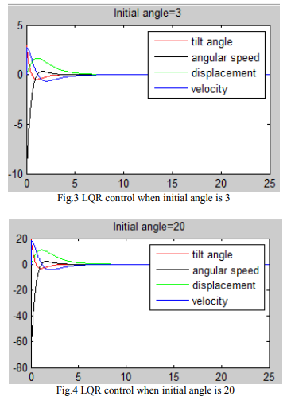
Figure 4 (a) LQR control when initial angle is 3. (b) LQR control when initial angle is 20 [24]
Niemann et al., 2004[25]focused on Compared to a single inverted pendulum system, the design of stabilising controllers for a double inverted pendulum system is more difficult. Due to nonlinearities and system constraints, the trade-off between robust stability and performance is challenging in controller design. Different control methods, such as H2, H∞, and μ-synthesis, are used to handle this tradeoff. The paper presents a complete design procedure, including system simulation, analysis, uncertainty modelling, design problem formulation, controller design, closed-loop system analysis, and microcontroller implementation, and validation on a laboratory system. Yao et al., 2008[26]talked about three alternative fuzzy controllers that use weight changing fuzzy inputs to stabilise inverted pendulum systems. An ideal feedback matrix is used to create the weight variable, which is then used to create the two new fuzzy input variables, x1 and x2. The lower, upper, and cart's error information are taken into account by the suggested fuzzy controllers. Their structure is simple and intuitively understandable.
Graichen et al., 2006 [27] presented a study on the use of feedforward, feedback, and experimental validation to regulate the swing-up of a double inverted pendulum mounted on a cart. The study provided free parameters in the intended output trajectory for the cart location and addressed the transition job as a nonlinear two-point boundary value issue of the internal dynamics. In order to ascertain the internal dynamics, the control was established by solving the two-point boundary value issue. The study's findings confirmed that the underactuated system produced the anticipated outcomes during the swing-up manoeuvre and improved feedforward trajectory accuracy. This indicates that combining feedforward and feedback control can be a successful tactic. Zhong et al., 2001[28] proposed a study on the energy and passivity-based control of a double inverted pendulum. The study proposed a nonlinear method using a sway-up controllerin the case of the twin inverted pendulum system. The main focus of this study was on the Lyapunov theory, which played an important role in the control design and convergence analysis. The study's findings revealed that combining the Lyapunov theory with passivity properties and energy shaping led to improvements in the effectiveness of achieving equilibrium for a nonlinear, underactuated mechanical system such as the two-inverted pendulum. This suggests that the use of energy and passivity-based control, along with the Lyapunov theory, is an effective strategy for the control of A dual inversion suspension system is used for swing-up control of a double inverted pendulum on a cart.
Zad et al., 2023 [29] proposed an adaptive control strategy for a self-balancing two-wheeled robot system using an adaptive model predictive controller (MPC)in accordance with real-time model estimate. The proposed controller updates the linearization process based on measurement data to obtain an optimal control for the nonlinear plant. The controller is simulated using MATLAB, and the performance is evaluated using step reference tracking. The evidence indicated that the proposed adaptive MPC controller is showing improved tracking accuracy and step-speed compared to the non-adaptive MPC controller
Kim et al., 2015[30]focused on the dynamic modeling of two-wheeled balancing mobile robots (2WBMRs) or inverted pendulum robots. These robots, with their compact design and versatility in urban areas, have gained attention for their driving efficiency and maneuverability. The review highlights the importance of a reliable dynamic model for designing control systems and evaluates existing challenges and modeling errors. It compares the Newtonian, Lagrangian, and Kane's methods for deriving the dynamic model of 2WBMRs and discusses the consequences of missing terms. By addressing the modeling errors and analyzing the effects of neglected terms, this contributes to enhancing the understanding and accuracy of dynamic modeling for 2WBMRs.
Gaffari et al., 2015[31]focused on the control of two-wheeled self-balancing robots and highlights the significance of considering a previously neglected nonlinear coupling term in their mathematical models. Existing control algorithms often overlook this term, which can have a significant impact on the system's dynamic behavior. Presented the derivation of the mathematical representation of these robots, incorporating the neglected term using Kane's and Lagrangian methods. Sliding-mode control techniques are then employed to design controllers that address path tracking and stability. Simulation results demonstrate the importance of accounting for the nonlinear coupling term in the controller design to effectively compensate for its effects. Overall,emphasizes the need for a comprehensive understanding of the system dynamics and contributes to advancements in the control of two-wheeled self-balancing robots.Andrzejewski et al., 2019 [32] presented a study on a comprehensive approach to the modelling of the twin inverted pendulum (DIP). The study focused exclusively on modelling the DIP using Euler-Lagrange formulae in the existence of external force and friction. The study considered possessions such as Point of equilibrium support, chaotic interactions, and behaviour outside of the optimum cycle near an upper location. The study provided extensive knowledge about the double inverted pendulum, which can be useful in the design and development of control strategies for the system. This suggests that the comprehensive approach proposed can be an effective strategy for modelling the double inverted pendulum system

CHAPTER 3

METHODOLOGY

The inverted pendulum system consists of a solid and uniform rod, which are connected by a revolute joint. The pendulum with mass m₁ is hinged to the cart and therefore has movement along x-axis following the cart. The system used is under-actuated and the force u(t) is the only input. This force is used to maneuver the two degrees of freedom of the system: the position of the cart X₀, angle of the lower pendulum $θ$(t).It may be noted that the angle measured are the absolute angle from the vertical line and not the relative angle in the analysis.

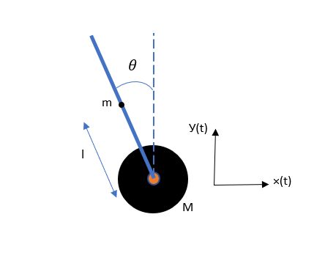

Figure 5 Free Body Diagram of a Simple Inverted Pendulum

3.1 DERIVATION OF GOVERNING EQUATION OF MOTION
The horizontal displacement of the cart, with time t being the reference, is represented by:
x₀ (t) (1)
The horizontal displacement and the vertical displacement of the center of the pendulum, with time t being the reference, is represented by:
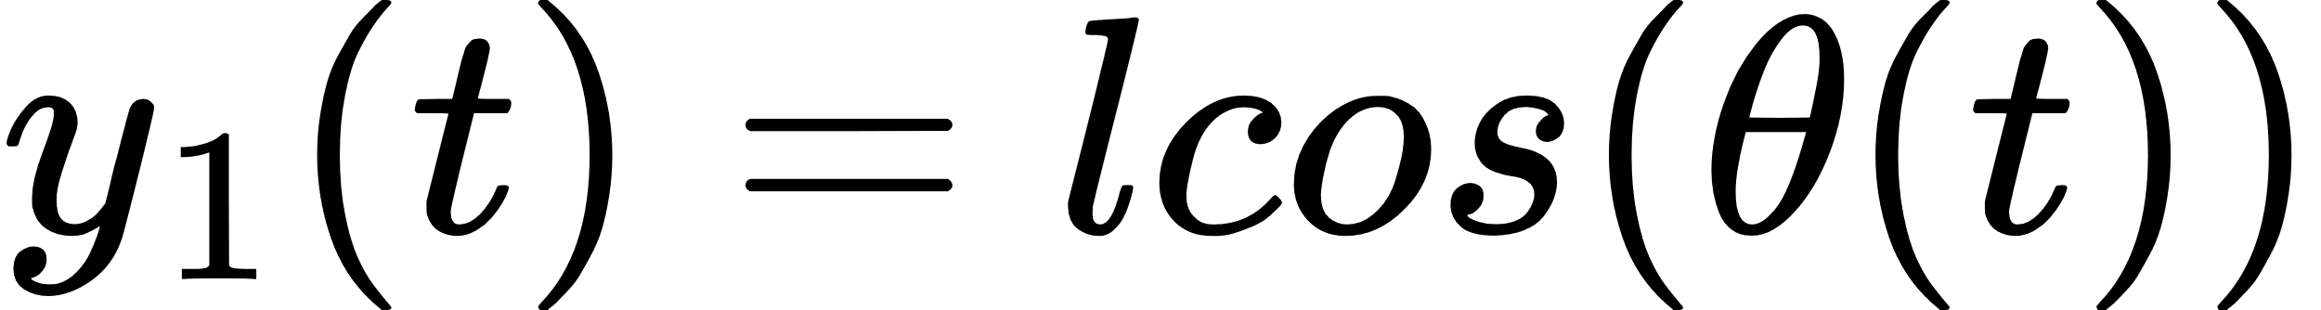
The difference between the total kinetic energy and the total potential energy of the system is given by the Lagrangian (L), which is represented by:

where, K.E represents the total kinetic energy of the system and P.Erepresents the total potential energy of the system
The kinetic energy of the system is represented by
The potential energy of the system is represented by

accordingly, L can be obtained as
Equations that represent the dynamics of the system are given by
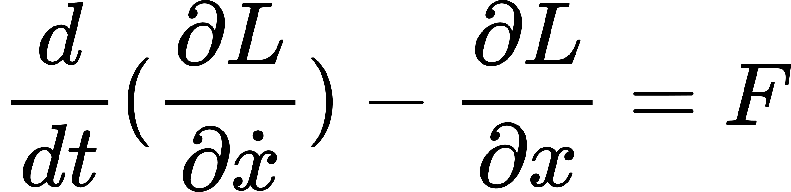

The equations are
Where,
m = mass of the pendulum
M = mass of the wheels
Also adding the friction(b), and moment of inertia of the system(I) the final equations of motion becomes
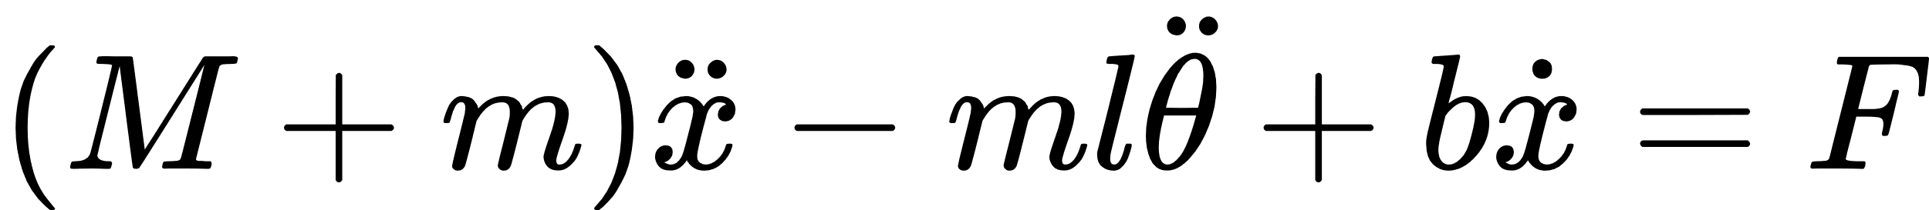
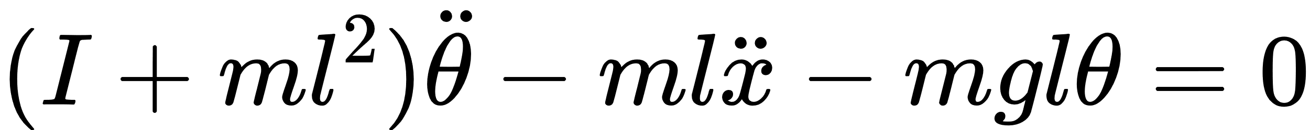

3.2 APPLYING STATE SPACE MODEL
By applying linearization to the governing equations of motion and rearranging them we get
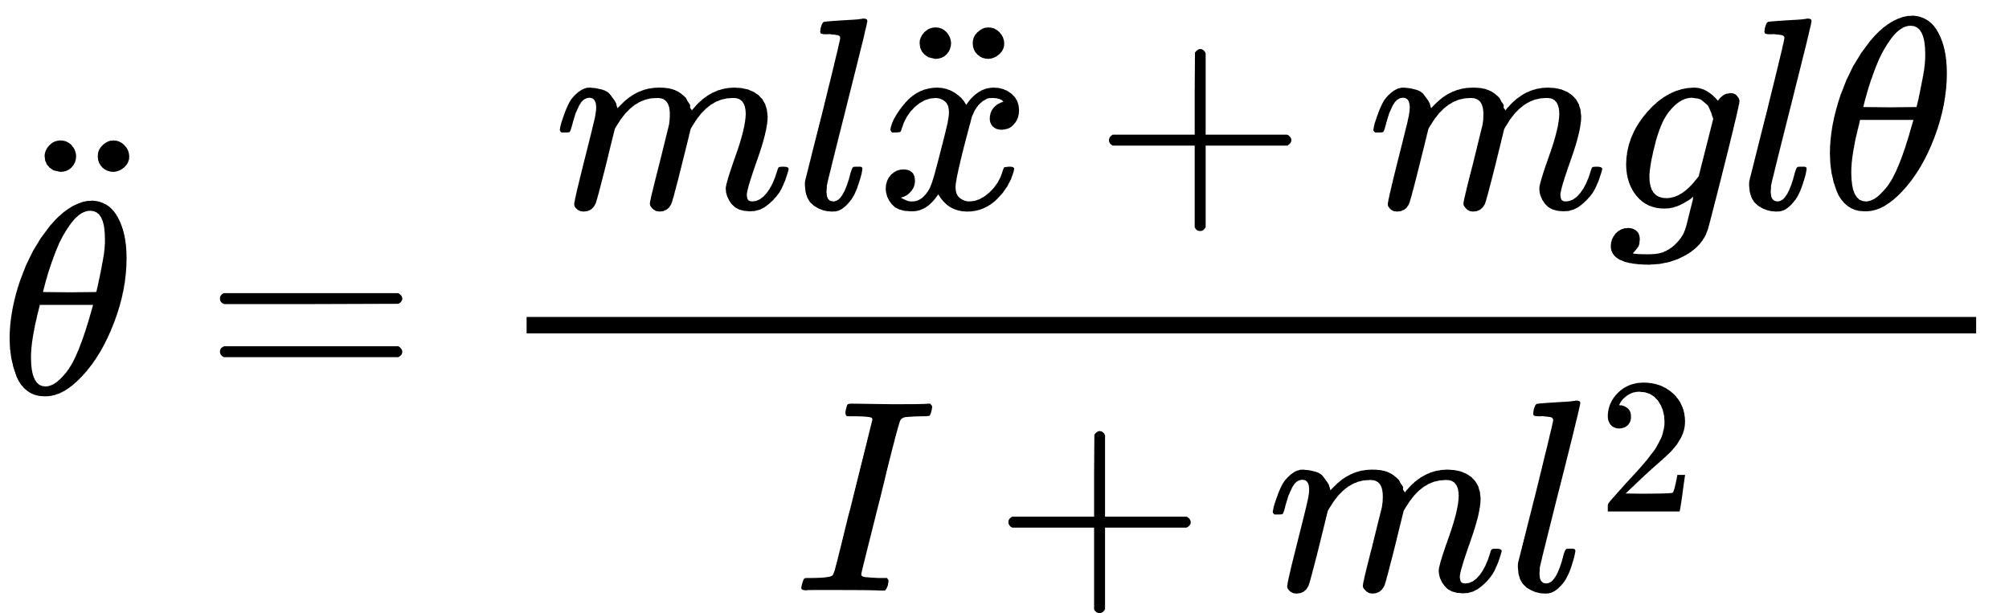

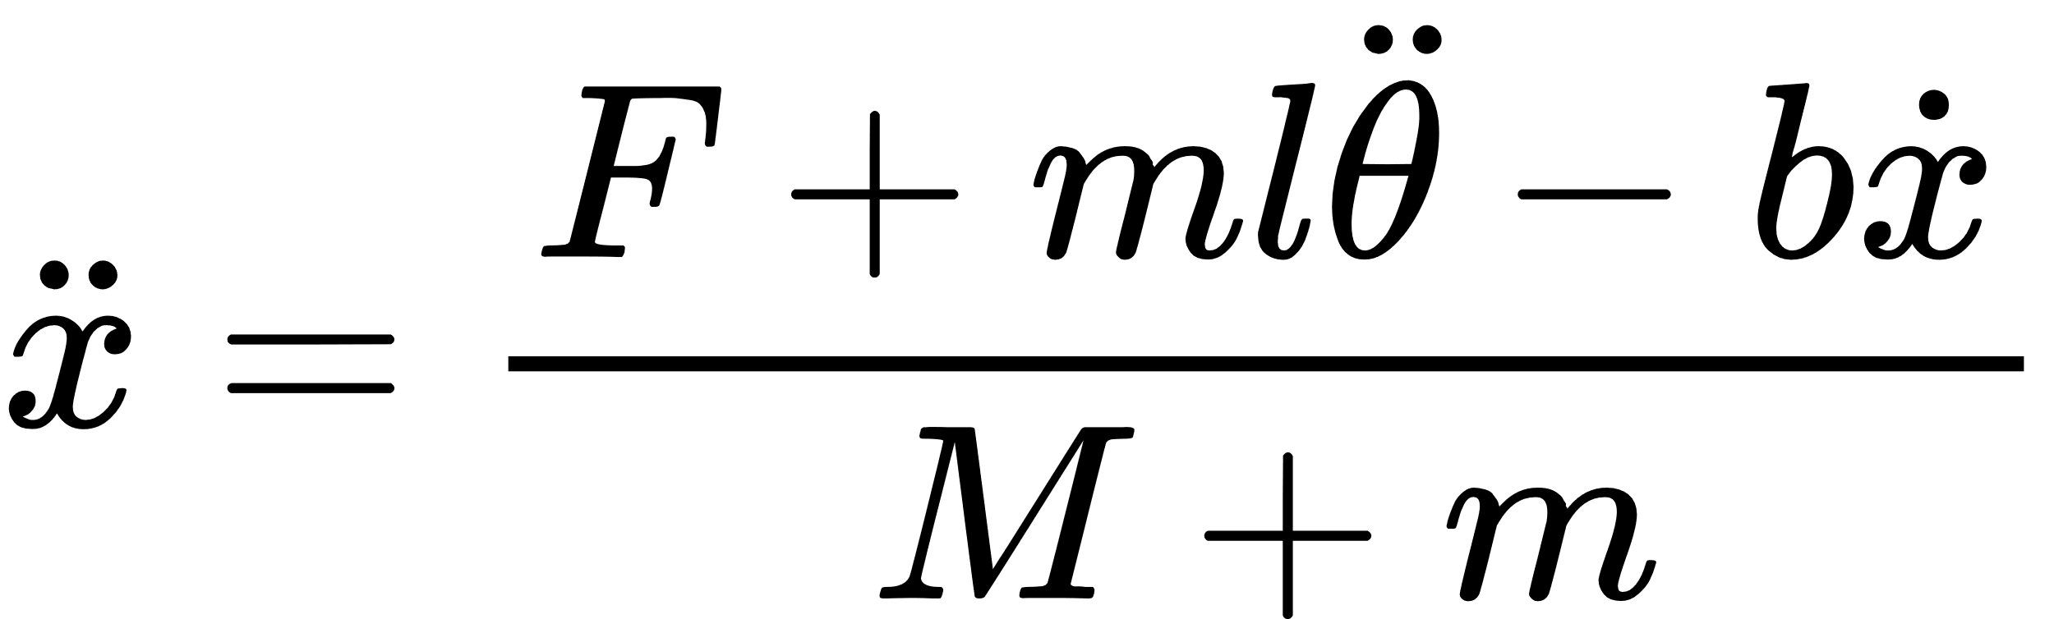
From this equations we get the state space equations as follows

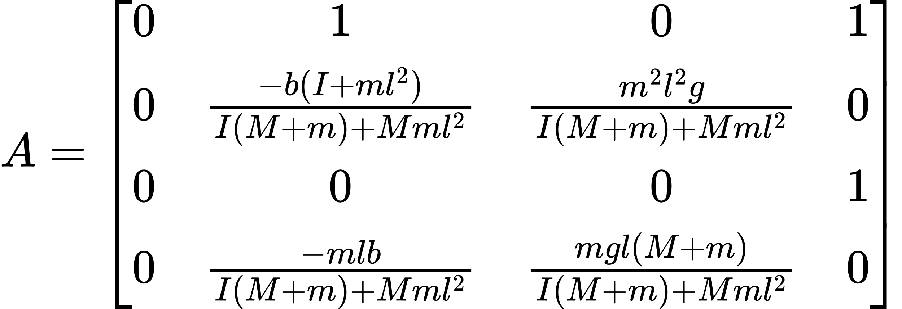

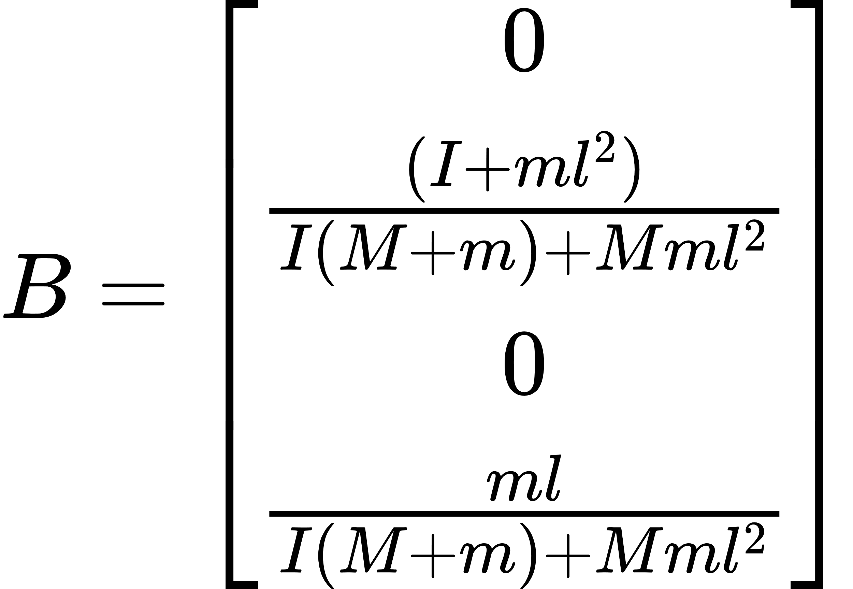

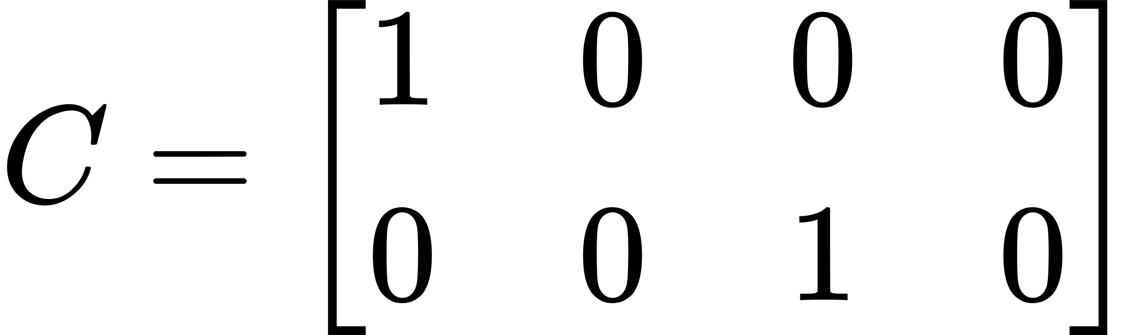

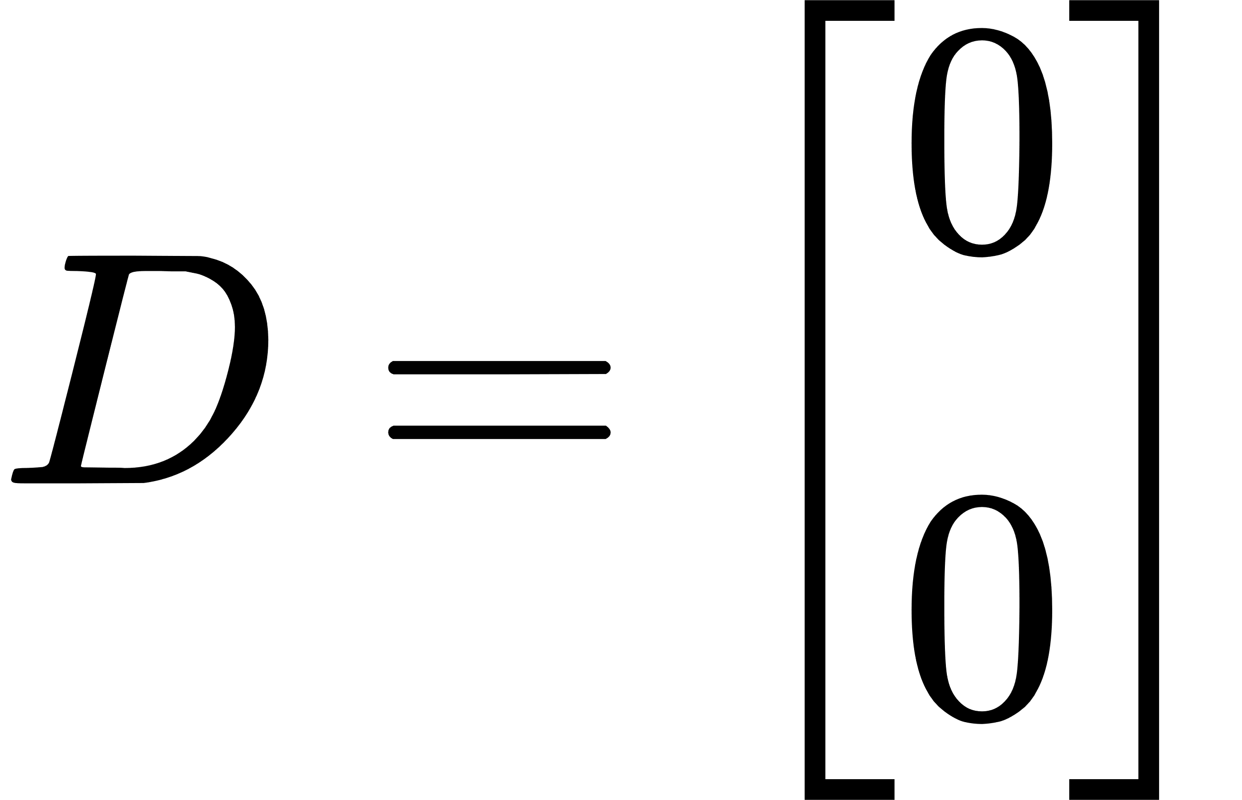

3.3 DESIGN OF THE ROBOT

3.3.1 STRUCTURAL DESIGN OF THE ROBOT
The structural design of the two-wheel self-balancing robot is based on the dimensional requirements of the electronics being used in it. The length of the robot, which is 300mm, has been determined based on the length of high-torque servo-motors with encoder, where two of them were used and the length each is 110mm. The width of the robot, which is 100mm, has been determined based on the width of Arduino Mega 2560, which is 54 mm.
The robot consists of five levels on to which the electronics were attached. The height of the robot has been determined based on the effective heights of various components placed in the five levels of the robot. The one at the bottom was utilized for the high-torque servo-motors which drive the wheels along with their motor driver, which is TA6586 Motor driver. The second level is dedicated for the electrical system of the robot. Battery and buck convertors in the circuit are held at place at this level. Placing the battery at this level resulted in obtaining the center of gravity of the robot at the desired location, i.e., the closer the point of intersection of the vertical central axis and horizontal central axis. The third level is utilized to house Arduino Mega 2560 and MPU6050 module. The fourth level houses the HC05 Bluetooth module and acts as the base for the ultra-high torque servo motor, which is used for the pan-joint. The fifth level is the hood of the robot; it contains the switch of the electrical circuit, which is placed at the location for ergonomic purposes. The pan and tilt joint of the robotic arm sits on the shaft-extension of the ultra-high torque servo motor which opens up at the fifth level. The aforementioned details can be better understood for the following figure. 6.

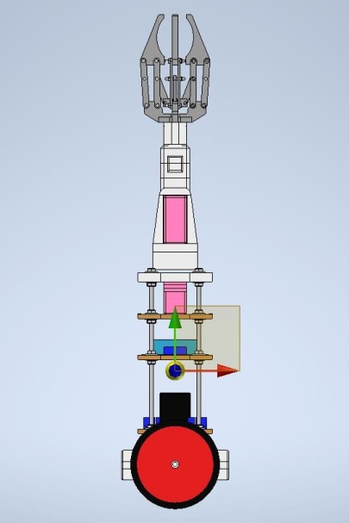
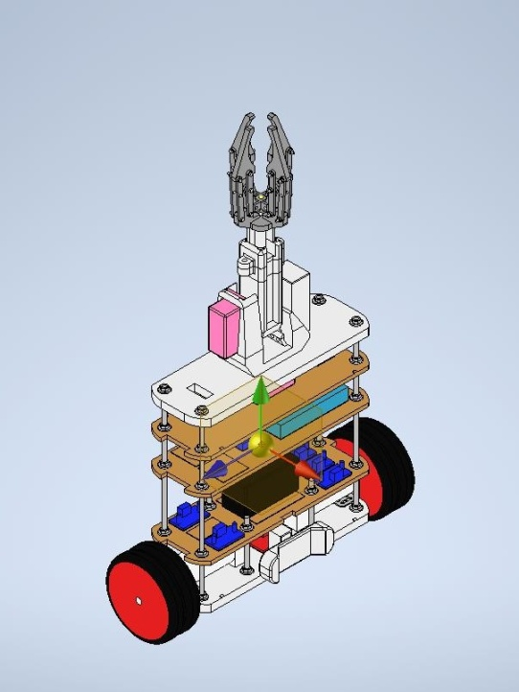
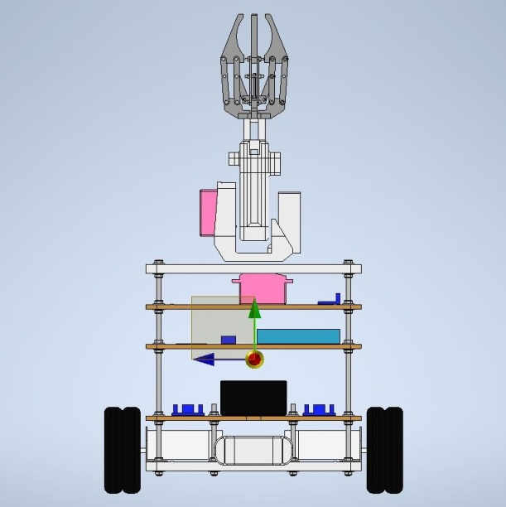
(c)
(b)
(a)
Figure 6Illustration of the structural design of the robot – (a) Front view; (b) Side view;
(c) Isometric view

The torque requirements of the wheel servo motors were identified though the following kinetics calculations
Distance of the center of gravity of the robot from the axis of rotation of the wheels (L) | = 13.2 cm
Mass of the robot (m) | = 3.8 Kg
Maximum permissible angle of tilt for the robot (ø) | = 45º
Torque required for tilt joint motor to operate balancing during the maximum tilt (T) | = m × g × Sin(45º) × L N.cm
 | = 3.8 × 9.8 × (1÷1.414) × 13.2
 | = 348 N.cm
Torque requirement of each of the two-wheel servo motors acting per motor | = (348 ÷ 2) N.cm
 | = 174 N.cm

3.3.2 FOUR-CLAW GRIPPER AND ITS KINEMATICS
The robotic arm at the top of the robot houses a four-claw gripper, which can be utilized to grip objects such as tomatoes, lemons etc. The four-claw gripper functions based on a Nut & bolt joint, i.e., the nut is attached to the central piece which constrains the four claws and the bolt which is attached to a 360⁰ Servo motor, drives this constrained central piece from bottom to top and vice-versa enabling the gripping and un-gripping actions respectively.
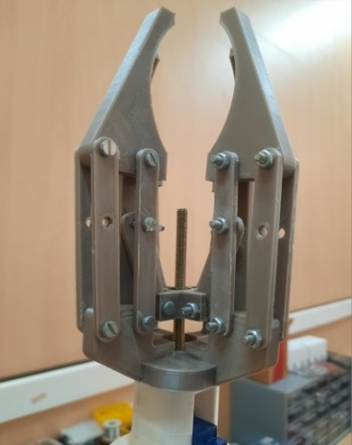
(c)

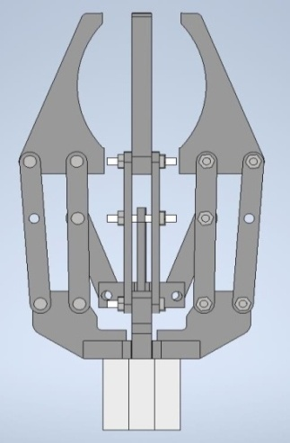
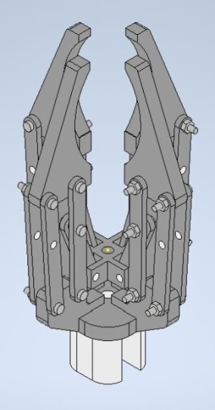
(b)
Claw
(a)

Constrained central piece

Figure 7Illustration of the four-claw-gripper – (a) Isometric view; (b) Side view; (c) Picture of the four-claw gripper with its driving bolt

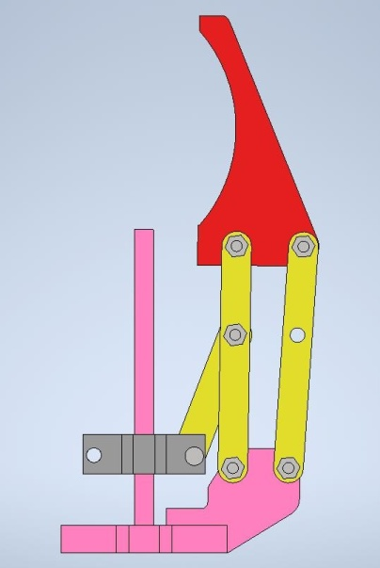

Figure 8– Illustration of a finger of the gripper

The kinematics of this mechanism is solved as follows.
In order to identify the number of degrees of freedom for each finger of the gripper Kutzbach criteria was used.
M = 3(n – 1) – 2j₁ – j₂
Where,
M = No. of degrees of freedom
n = Total no. of links
j₁ = No. of lower link-pairs (i.e., links which have surface contact at their joint. E.g. revolute joint or fixed joint etc.)
j₂ = No. of higher link-pairs (i.e., links which have line or point contact at their joint. E.g. spherical joint etc.)
here,
n = 6
j₁ = 7
j₂ = 0
M = 3(6-1) – 2(7) – 0
M = 1
Therefore, the no. of degrees of freedom for each finger of the gripper in one, i.e., constrained movement in a single plane.

3.3.3 ROBOTIC ARM AND ITS KINETICS
The Robotic arm has two degrees of freedom, i.e., it can tilt from back to front & vice versa and it can rotate 90º from the center to far-left and then 170º from far-left to far-right. These degrees of freedom are enabled using the pan and tilt joint, which is driven by two ultra-high torque servo motors.

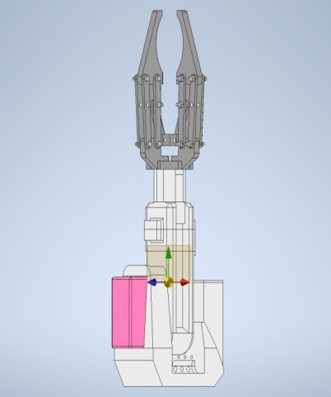
Pan - Degree of Freedom
Tilting - Degree of Freedom
Figure 9Illustration of the robotic arm and its degrees of freedom of movement
The overall length of this robotic arm from the axis of rotation to the tip of the tip of the four-claw gripper is 210mm. The point at which the center of gravity of the robotic arm lies is 60mm from the axis of rotation.
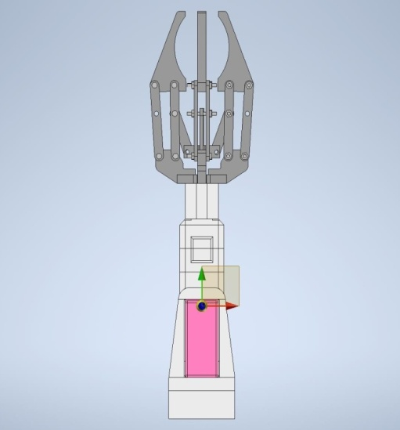
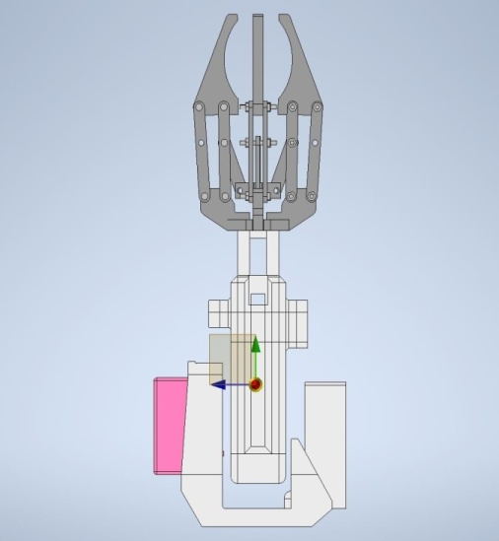
(b)
(a)
Figure 10Illustration of the Centre of gravity of the robotic arm – (a) Front view;
(b) Side view

The torque requirements of this robotic arm were identified though the following kinetics calculations:
Torque requirements for the tilt joint’s motor:
Length of the link of the robotic arm | = 15 cm
Length of the gripper | = 14 cm
Total length of the robotic arm | = 29 cm
Distance of the center of gravity of the link and the gripper from the axis of rotation of the tilt joint | = 21 cm
Weight of the link | = 110 g
Weight of the gripper | = 95 g
Weight of the servo motor and the fasteners | = 40 g
Maximum weight of the payload | = 500 g
Total load applied on the tilt joint | = 745 g
(i.e., 110 g + 95 g + 40 g + 500 g = 745 g = 0.745 Kg)
Torque required for tilt joint motor to operate tilting action | = 0.745 Kg X 21 cm
 | = 15.645 Kg.cm

Torque requirements for the pan joint’s motor:
Maximum distance of the center of gravity of the pan joint from the axis of rotation | = 6.7 cm
Weight of the pan joint | = 235 g
Weight of the tilt joint, which transfers on to the pan joint | = 245 g
Maximum weight of the payload | = 500 g
Total load applied on the tilt joint | = 980 g
(i.e., 235 g + 245 g + 500 g = 980 g = 0.98 Kg)
Torque required for pan joint motor to operate pan action | = 0.98 Kg X 6.7 cm
 | = 6.56 Kg.cm

3.3.4 FABRICATION TECHNIQUES OF THE ROBOT
The structure of the robot can either be 3D Printed or be assembled using wood-machined sheets and M6 300mm rods. The former shall be referred to as Mk7 version and the later shall be referred to as Mk3 version. Wood-machined sheets version (Mk7 version) was chosen considering the cost and fabrication time. When compared with the 3D Printed version (Mk3 version), Wood-machined sheets version (Mk7 version) is 1.9 Kg lighter. The structural assembly of the Mk7 version is illustrated in the figure 6.

Table 1Comparison of fabrication techniques
S. No | Parameter | 3D Printing  (Mk3 version) | Sheet Fabrication  (Mk7 version)
1 | Bare Structural weight of the robot | 3.5 Kg | 2.2 Kg
2 | Weight of the electronic components | 2.2 Kg | 1.6 Kg
3 | Total weight of the robot | 5.7 Kg | 3.8 Kg
4 | Materials cost for fabrication | Rs. 3,500 | Rs. 1,500
5 | Outsourcing cost | Rs. 35,000 | Rs. 7,500
6 | Total Cost of fabrication | Rs. 38,500 | Rs. 9,000
 | Fabrication time | 20 Days  (If 1* Creality CR10 3D Printer is available) | 2 Days

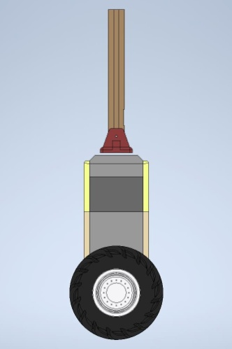
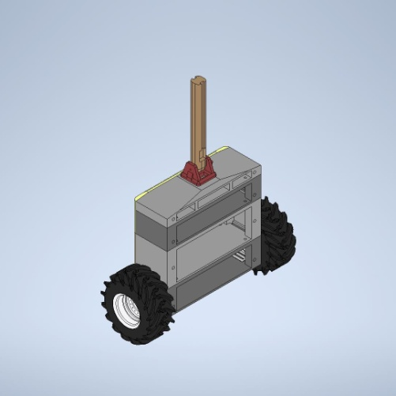
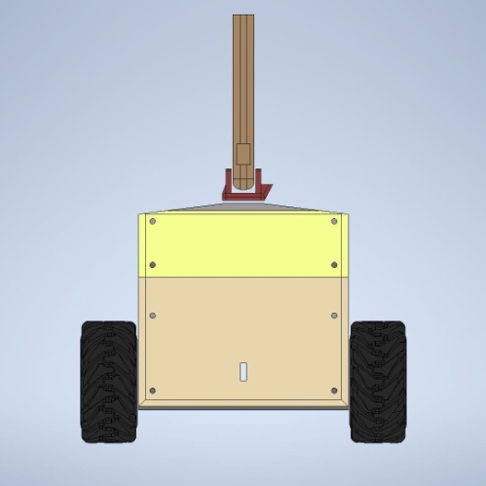
(c)
(b)
(a)
Figure 11Illustration of the Mk3 version – (a) Front view; (b) Side view;
(c) Isometric view of the assembly of the four 3D printable blocks

The Mk3 version’s model has four blocks into which the five levels of the robot are incorporated. Each of the four blocks were designed to be 3D Printed individually and then assembled with nuts and bolts. The structural load bearing columns were integrated into the block design of the Mk3 version, while M6 300mm rods along with the appropriate Nuts and washers were utilized for as the structural load bearing columns for the Mk7 version.
In the case of Mk3 version, the sides of the robot are covered by default, according to the design. The front and back can be enclosed with 3D printed enclosure plates. On the other hand, in the case of Mk7 version, the enclosure on all four sides of the robot is implemented using 0.25 mm thick mylar sheets which are cut according to the dimensional requirements.
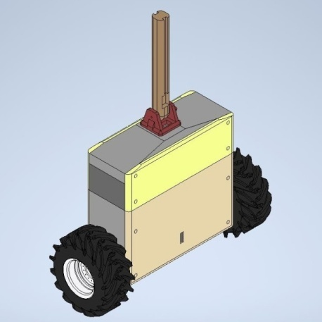
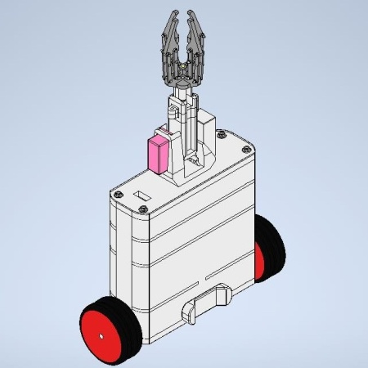
(a)
(b)

Figure 12Comparison of enclosures – (a) Mk3 version; (b) Mk7 version
The wheels in the Mk 3 version were of the diameter 170mm and were intended to be 3D printed using TPU filament. Due to 3D printer availability constraints, Mk7 version utilizes the readily available 125mm diameter wheels.
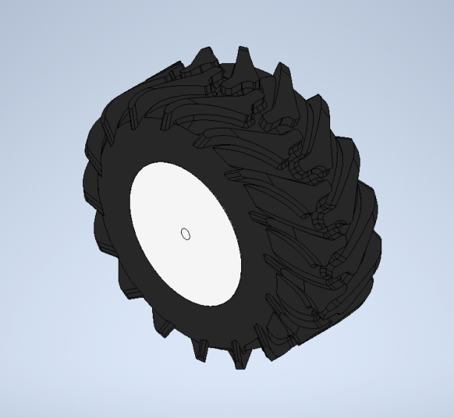
(a)

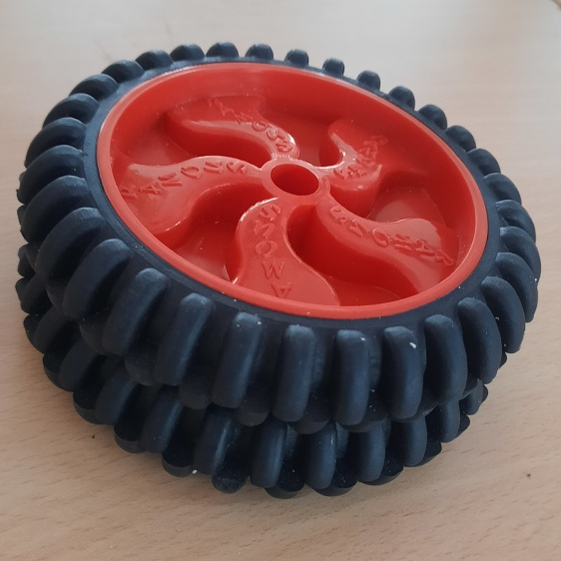
(b)

Figure 13Comparison of the wheels – (a) Mk3 version’s 170mm diameter wheels;
(b) M7 version’s 125mm diameter wheels

3.4 ELECTRONICS AND CIRCUIT DIAGRAM
Arduino Mega 2560 was considered as the micro controller for the robot because of its large number of IO available, which meets the requirements. The angle of tilt of the robot is sensed using the MPU6050 module. Two of them were used, one for the robot’s structure and the other for the robotic arm. The sensing of translational movement of the robot is done with OE37 Hall-effect rotary encoder modules, which were attached to the wheel servo motors. The wheel servo motors are controlled using TA6586 motor driver.
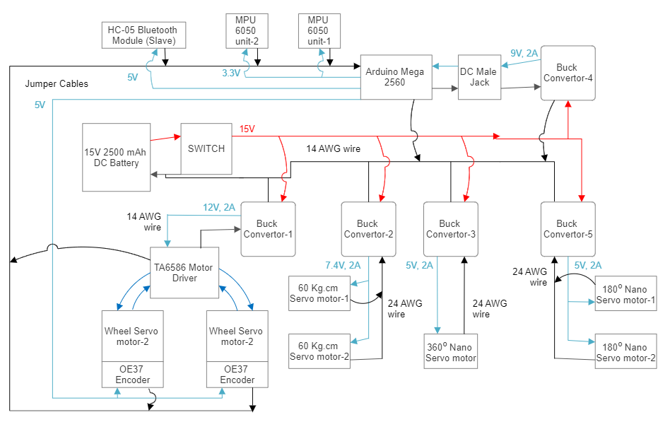
Figure 14Integrated electrical circuit diagram of the robot and the robotic arm
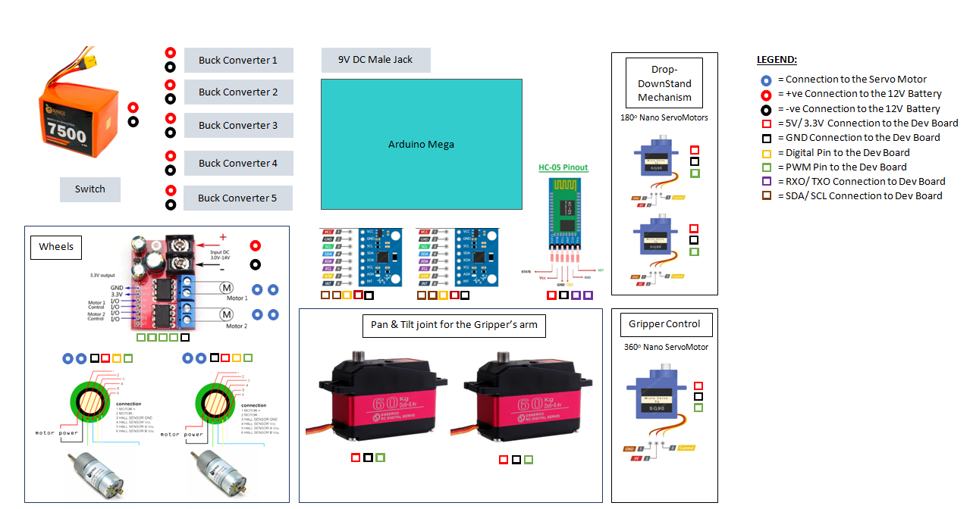

Figure 15Sensors Input-Output ports diagram for the robot and the robotic arm

The custom designed console is utilized to control the directional movement of the robot and the actions of the robotic arm. The console uses Arduino Nano as its micro-controller. The forward & backward and Right & Left movement of the robot is controlled using the thumb-joystick modules on the console. The Pan and tilt movement of the robotic arm are controlled using the rotary encoder modules on the console. Gripping and un-gripping actions of the four-claw gripper are controlled using push buttons on the console, The communication between the console and the robot is achieved using the HC-05 Bluetooth modules. The Bluetooth module attached to the robot was configured as a slave and the one attached to the console was configured as the master.
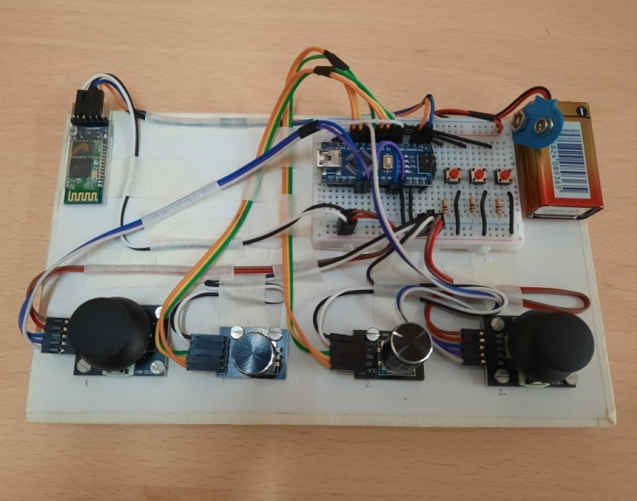
Figure 16Picture of the console
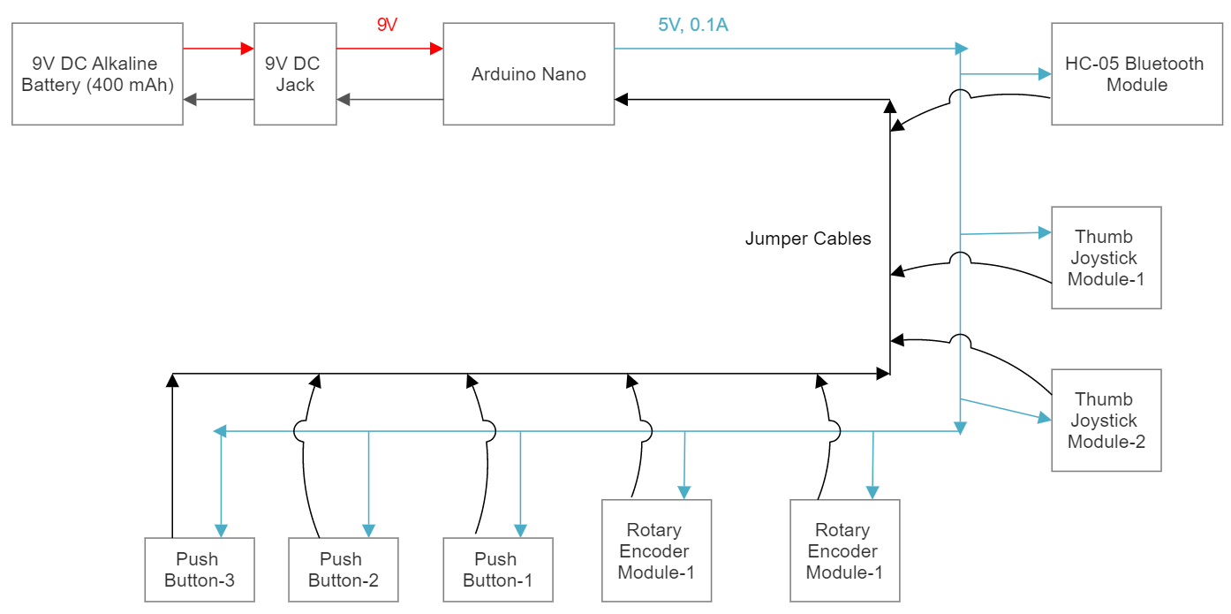

Figure 17 Circuit diagram of the console

3.5 DESIGN OF CONTROL SYSTEM
Table 2Parameters of the inverted - pendulum
Description of the parameter | Magnitude value | Unit
Mass of the wheels, m | 0.6 | Kg
Mass of Pendulum, M | 3.8 | Kg
Earth’s gravity, g | 9.81 | m/s²
Centre of gravity of pendulum, l | 0.120 | m
Moment of inertia of the rod, I | 0.02050 | kgm²
Friction coefficient | 0.1 | Ns/m

The system is unstable if any of the poles of the system have positive real parts so we employ a control system in order to move the poles to the left half of the s-plane such that all poles of negative real parts. By plugging in the parameters in A, B, C, D matrices we get the following









The poles of the open loop system are located at 0, -0.0172, -13.6985 and 13.6631as you can see one of the poles is on the right half of the s-plane so the system is inherently unstable so we need to employ a control system such that the poles are placed on the left half of the s-plane.

3.5.1 SIMULATION OF POLE-PLACEMENT CONTROL TECHNIQUE
Pole-placement techniques which is also referred to as full state feedback is implemented, for feedback control system, by placing the closed-loop poles of the system on locations in the s-plane, which are in predetermined. An important condition that must be satisfied to implement this system is that the system must be completely state controllable for placing a pole at a random point.

The desired pole of the system are[-1.0+1.36i, -1.0-1.36i, -4.9, -5]. And the gains are calculated using the place function of MATLAB. The gain matrix is as follows
K_pole = [-1.7650, -2.0519, 55.1395, 3.2635]. The system is simulated using the gain matrix and the results are recorded.

3.5.2 SIMULATION OF LQR CONTROL TECHNIQUE
LQR control technique takes the Q matrix, which represents the cost functions to states deviation, and the R matrix, which represents control input, into account. This control technique is widely regarded as the optimal control scheme due to its ability of accomplishing the desired objective with minimal consumption of available resources.

The weight matrices that have been used for calculating are given below
Q = diag([150,50,200,10])
R = 0.01
The values have been taken such that more penalty is applied when the system is not in the required position and upright
To obtain the gain matrix K_LQR the LQR function of MATLAB is used
The gain matrix obtained from this is:
K_LQR = (-12.2474, -15.0435, 112.5687, 10.5238)

The system is simulated and the results are recorded

CHAPTER 4

RESULT & DISCUSSION

4.1 RESPONSES OF THE SYSTEM FROM THE POLE-PLACEMENT CONTROL TECHNIQUE
The responses from the simulation of the Pole-placement control technique of the inverted – pendulum system are illustrated in the following figures. The plot in figure 18(a) represents the movement of the cart with respect to the reference taken at the start of the simulation. While the plot in figure 18(b) represents the angle θ.
(b)
(a)
Figure 18 The response Pole-placement control (a) The change in position of the cart with respect to time, (b) The change in the angle $θ$with respect to time.
4.2 RESPONSES OF THE SYSTEM FROM THE SIMULATION OF LQR CONTROL TECHNIQUE
The responses from the simulation of the LQR control technique of the inverted – pendulum system are illustrated in the following figures. The plot in Figure 19(a) represents the movement of the cart with respect to the reference taken at the start of the simulation. While the plot in figure 19(b) represents the angle$θ$.

(a)
(b)

Figure 19 The response of LQR control (a) The change in position of the cart with respect to time, (b) The change in the angle $θ$with respect to time

4.3 ANALYSIS OF THE RESPONSES AND DISCUSSION
The rising time T_{r} and the setting time T_{s} for the position of the cart, the angle $θ$ are taken as the output responses from the system. These three parameters represent the performance of the control system in stabilizing the inverted double pendulum. The rising time indicates the responsiveness of the control system while the settling time represents the amount of time taken for the system to attain balance after the induction of the input load. The exact values of the two aforementioned parameters for the position of the cart, angle $θ$are depicted in Table 3. figure 20shows the step response for Pole-placement control scheme and LQR control scheme respectively.
Table 3 The simulation results of Rising time, Settling time for the cart, angle $θ$, in seconds
 |  | Pole-placement control technique  Time (s) | LQR control technique  Time (s)
For angle $θ$ | T_{r} | 0 | 4.4409e-16
 | T_{s} | 5.1326 | 3.6574
For position x | T_{r} | 1.1821 | 1.6409
 | T_{s} | 3.9312 | 2.7590

(a)

(b)

Figure 20(a) The step response of LQR control, (b) The step response of pole-placement control

It can be comprehended by observing table 3 that Pole-placement control scheme is only effective in responsiveness for the position of the cart. However, LQR control scheme is better in responsiveness for the angle $θ$and also in stabilizing the system in all the two considered outputs. Considering the better performance of the LQR control scheme, further research will be focused on improving the mathematical model to incorporate the disturbance caused by the cart motion on uneven terrain.

CHAPTER 5

CONCLUSION AND FUTURE WORK

The mathematical model of the double inverted pendulum on a cart was developed using Euler-Lagrange equation. Pole-placement, LQR and PID control techniques were individually implemented and the performance of each of these controllers with respect to the stability of the double inverted pendulum was observed through MATLAB simulation. From the simulation results, it can be comprehended that the LQR control technique shows better responsiveness in attaining stability over the Pole-placement and PID technique. For the selected system, the settling time for the outer pendulum in LQR scheme is observed to be three times shorter compared to the pole placement technique. This indicates that LQR scheme can be adopted for controlling systems that require faster settling time. As a sub case the analysis is implemented on a single inverted pendulum. A prototype of the single inverted pendulum with an arm and a gripper is built. The necessary motors, motor drivers, buck converters, microcontroller, power sources are selected to develop the prototype. The developed prototype is tested for closed loop operation in-situ. The test and evaluation of the robot are being conducted on the prototype for validating the self-balancing demonstration on different terrains. We believe that the present study provided insights into developing a robot prototype, address integration challenges, implementing and validating the performance of two control schemes for systems with more complicated dynamics.
The prototype of the robot is tested for arbitrary input angles and verified for the ability to self-balance on plane surfaces. The future scope for improvements include scaling down the prototype, adding improvements such as independent wheel control, robust control for arbitrary disturbance, extension to double inverted pendulum, including on-board storage system, providing computer vision and making it run through Artificial Intelligence (AI) with edge computation. The work can be also done in terms of attaching a telescopic arm and furthermore, extensive uneven terrain testing can be done on inverted pendulum cart systems.

REFERENCES
[1] J. Velagic, I. Kovac, A. Panjevic, and A. Osmanovic, “Design and Control of Two-Wheeled and Self-Balancing Mobile Robot,” in Proceedings Elmar - International Symposium Electronics in Marine, Croatian Society Electronics in Marine - ELMAR, Sep. 2021, pp. 77–82. doi: 10.1109/ELMAR52657.2021.9550938.
[2] Institute of Electrical and Electronics Engineers Singapore Section Control Systems Chapter, Annual IEEE Computer Conference, IEEE Conference on Decision and Control, IEEE International Conference on Control and Automation 10 2013.06.12-14 Hangzhou, and IEEE ICCA 10 2013.06.12-14 Hangzhou, 10th IEEE International Conference on Control and Automation (ICCA), 2013 12-14 June 2013, Hangzhou, China.
[3] Strategic Technology (IFOST), 2010 International Forum on : date, 13-15 Oct. 2010. IEEE, 2010.
[4] A. T. Azar, H. H. Ammar, M. H. Barakat, M. A. Saleh, and M. A. Abdelwahed, “Self-balancing Robot Modeling and Control Using Two Degree of Freedom PID Controller,” in Advances in Intelligent Systems and Computing, Springer Verlag, 2019, pp. 64–76. doi: 10.1007/978-3-319-99010-1_6.
[5] IEEE Robotics and Automation Society, Annual IEEE Computer Conference, IEEE International Conference on Robotics and Biomimetics 2013.12.12-14 Shenzhen, and ROBIO 2013.12.12-14 Shenzhen, IEEE International Conference on Robotics and Biomimetics (ROBIO), 2013 Shenzhen, China, 12-14 Dec. 2013.
[6] E. Ahmad, A. Ur Rehman, O. Khan, M. Haseeb, and N. Ali, “Backstepping control design for two-wheeled self balancing robot,” in Proceedings - 2018, IEEE 1st International Conference on Power, Energy and Smart Grid, ICPESG 2018, Institute of Electrical and Electronics Engineers Inc., Jun. 2018, pp. 1–6. doi: 10.1109/ICPESG.2018.8384494.
[7] Universidade do Algarve, IEEE Industrial Electronics Society, and Institute of Electrical and Electronics Engineers, Proceedings of 2017 4th Experiment@ International Conference (exp.at’17) : Online Experimentation : date and venue: 6-8 June 2017, Faro, Portugal.
[8] M. K. Habib and S. A. Ayankoso, “Modeling and Control of a Double Inverted Pendulum using LQR with Parameter Optimization through GA and PSO,” in 2020 21st International Conference on Research and Education in Mechatronics, REM 2020, Institute of Electrical and Electronics Engineers Inc., Dec. 2020. doi: 10.1109/REM49740.2020.9313893.
[9] SVS College of Engineering and Institute of Electrical and Electronics Engineers, Proceedings of the 2018 International Conference on Current Trends towards Converging Technologies : 01-03, March 2018.
[10] N. Singh and S. Kumar Yadav, “Comparison of LQR and PD controller for stabilizing Double Inverted Pendulum System,” 2012.
[11] L. Wang and Z. Sheng, “LQR-Fuzzy control for double inverted pendulum,” in Proceedings - 2010 International Conference on Digital Manufacturing and Automation, ICDMA 2010, 2010, pp. 900–903. doi: 10.1109/ICDMA.2010.170.
[12] S. K. Yadav and M. N. Singh, “Optimal Control of Double Inverted Pendulum Using LQR Controller,” 2012. [Online]. Available: www.ijarcsse.com
[13] Nalavade, “Balancing Double Inverted Pendulum on A cart by Linearization Technique.”
[14] A. Bogdanov, “Optimal Control of a Double Inverted Pendulum on a Cart Cockpit passive optical helmet tracker View project MEKF-based Inertial Navigation System View project,” 2016. [Online]. Available: https://www.researchgate.net/publication/250107215
[15] D. T. Ratnayake and M. Parnichkun, “LQR-Based Stabilization and Position Control of a Mobile Double Inverted Pendulum,” in IOP Conference Series: Materials Science and Engineering, Institute of Physics Publishing, Jul. 2020. doi: 10.1088/1757-899X/886/1/012034.
[16] Siradjuddin, “State space control using LQR method for a cart-inverted pendulum linearised model”.
[17] Institute of Electrical and Electronics Engineers Singapore Section Control Systems Chapter, Annual IEEE Computer Conference, IEEE Conference on Decision and Control, IEEE International Conference on Control and Automation 10 2013.06.12-14 Hangzhou, and IEEE ICCA 10 2013.06.12-14 Hangzhou, 10th IEEE International Conference on Control and Automation (ICCA), 2013 12-14 June 2013, Hangzhou, China.
[18] National University of Sciences and Technology. School of Mechanical and Manufacturing Engineering and Institute of Electrical and Electronics Engineers, 2014 International Conference on Robotics and Emerging Allied Technologies in Engineering (iCREATE) : April, 22-24, 2014, Islamabad, Pakistan.
[19] C. Wang, Hubei-Gongye-Daxue Wuhan, Hua zhongke ji da xue, International Workshop on Intelligent Systems and Applications 2 2010.05.22-23 Wuhan, and ISA 2 2010.05.22-23 Wuhan, 2nd International Workshop on Intelligent Systems and Applications (ISA), 2010 22-23 May 2010, Wuhan, China ; proceedings.
[20] A. IEEE Industrial Electronics Society. Conference (39th : 2013 : Vienna, TechnischeUniversität Wien, Austrian Institute of Technology, IEEE Industrial Electronics Society, and Institute of Electrical and Electronics Engineers, IECON 2013-39th Annual Conference of the IEEE Industrial Electronics Society : proceedings : Austria Center Vienna, Vienna, Austria, 10-14 November, 2013.
[21] F. Dai, X. Gao, S. Jiang, W. Guo, and Y. Liu, “A two-wheeled inverted pendulum robot with friction compensation,” Mechatronics, vol. 30, pp. 116–125, Sep. 2015, doi: 10.1016/j.mechatronics.2015.06.011.
[22] J. Wu, Y. Liang, and Z. Wang, “A robust control method of two-wheeled self-balancing robot,” in Proceedings of the 6th International Forum on Strategic Technology, IFOST 2011, 2011, pp. 1031–1035. doi: 10.1109/IFOST.2011.6021196.
[23] S. Jadlovská and J. Sarnovský, “Classical double inverted pendulum - A complex overview of a system,” in IEEE 10th Jubilee International Symposium on Applied Machine Intelligence and Informatics, SAMI 2012 - Proceedings, 2012, pp. 103–108. doi: 10.1109/SAMI.2012.6208937.
[24] L. Wang and Z. Sheng, “LQR-Fuzzy control for double inverted pendulum,” in Proceedings - 2010 International Conference on Digital Manufacturing and Automation, ICDMA 2010, 2010, pp. 900–903. doi: 10.1109/ICDMA.2010.170.
[25] H. Niemann and J. K. Poulsen, “Design and analysis of controllers for a double inverted pendulum,” 2005.
[26] Institute of Electrical and Electronics Engineers., Innovative Computing Information and Control, 2008, ICICIC ’08, 3rd International Conference on : date, 18-20 June 2008. [IEEE], 2008.
[27] K. Graichen, M. Treuer, and M. Zeitz, “Swing-up of the double pendulum on a cart by feedforward and feedback control with experimental validation,” Automatica, vol. 43, no. 1, pp. 63–71, Jan. 2007, doi: 10.1016/j.automatica.2006.07.023.
[28] W. Zhong and H. Röck, “Energy and passivity based control of the double inverted pendulum on a cart,” in IEEE Conference on Control Applications - Proceedings, 2001, pp. 896–901. doi: 10.1109/cca.2001.973983.
[29] H. S. Zad and A. Ulasyar, “Adaptive Control of Self-Balancing Two-wheeled Robot System based on Online Model Estimation.”
[30] S. Kim and S. J. Kwon, “Dynamic modeling of a two-wheeled inverted pendulum balancing mobile robot,” Int J Control Autom Syst, vol. 13, no. 4, pp. 926–933, Aug. 2015, doi: 10.1007/s12555-014-0564-8.
[31] A. Ghaffari, A. Shariati, and A. H. Shamekhi, “A modified dynamical formulation for two-wheeled self-balancing robots,” Nonlinear Dyn, vol. 83, no. 1–2, pp. 217–230, Jan. 2016, doi: 10.1007/s11071-015-2321-9.
[32] K. Andrzejewski, M. Czyżniewski, M. Zielonka, R. Łangowski, and T. Zubowicz, “A comprehensive approach to double inverted pendulum modelling,” Archives of Control Sciences, vol. 29, no. 3, pp. 459–483, 2019, doi: 10.24425/acs.2019.130201.

